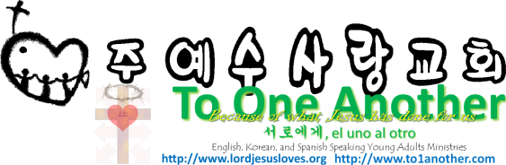
Thanksgiving
Pastor Yoo Nam Kang
Ephesians 5:20
Scriptures in New Living Translation
November 18, 2012

Ephesians 5:20
And give thanks for everything to God the Father in the name of our Lord Jesus Christ.

1. Feast of Tabernacle
Deuteronomy 16:13
You must observe the Festival of Shelters for seven days at the end of the harvest season, after the grain has been threshed and the grapes have been pressed.

Seven Observances
- Passover = The Cross
- Feast of Unleavened Bread = The Grave
- Feast of Firstfruits = Salvation
- Feast of Weeks = Pentecost – the coming of the Holy Spirit
- Feast of rim = The Resurrection
- Day of Atonement = Complete Atonement of Sins
- Feast of Booths = The Millennial Kingdom = Thanksgiving
* Holy Celebration = Eternal heaven

Deuteronomy 16:16-17
16 “Each year every man in Israel must celebrate these three festivals: the Festival of Unleavened Bread, the Festival of Harvest, and the Festival of Shelters. On each of these occasions, all men must appear before the Lord your God at the place he chooses, but they must not appear before the Lord without a gift for him. 17 All must give as they are able, according to the blessings given to them by the Lord your God.

2. Being Thankful in All Circumstances
Ephesians 5:20
And give thanks for everything to God the Father in the name of our Lord Jesus Christ.

3. Living the Life of Jesus
Matthew 1:21
And she will have a son, and you are to name him Jesus, for he will save his people from their sins.
Titus 1:3
And now at just the right time he has revealed this message, which we announce to everyone. It is by the command of God our Savior that I have been entrusted with this work for him.
Mark 1:38
But Jesus replied, “We must go on to other towns as well, and I will preach to them, too. That is why I came.”

